Seminal Infant Toddler 0-3

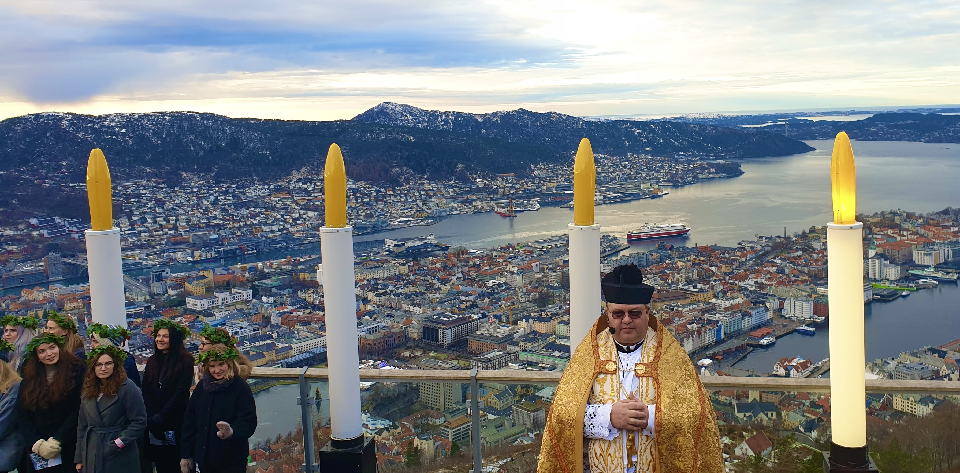
Catechesis of the Good shepherd formation

BERGEN, Norway, 26th April – 8^{th May} 2026
What is the 0-3 Formation about?
The Catechesis of The Good Shepherd is a profound and essential way of meeting the spiritual needs of the human person at every stage of development. A way in which we ponder, together with our fellow pilgrims, both children and adults:
“Who are You Lord?” “Who am I?” “Who are You, O Lord?”
Listening to His voice in our prayer and in His Word, our journaling with small and whole group reflections, timelines of development in the womb and up to age 3, Montessori theory and pedagogy will all serve and guide us as we ponder the themes of: Creation, Humanity, Prayer, Ancestry, Marriage, Birth, Baptism, the future of the Church, and how to live the life of The Good Shepherd following His voice through the seasons in practical life work, liturgy and celebration.

We ask together how we best do this with the very youngest, sharing organic possibilities of how we might nurture the spiritual life of the very youngest child in the environments of: Nature, the Womb, the Home, the Church, the Nido (Ital. ‘nest’) Atrium and the Toddler Atrium.
Together we ponder: Who this child is? What have they revealed to us about themselves? About us? and about our Creator?
In light of the revelation of the child, how are we called by the Holy Spirit to respond to them? What experiences and materials might we offer them to nurture the relationship they already have with the Good Shepherd?
Who is this formation for? The Infant Toddler Catechesis Formation is for mature adolescents (who desire this for themselves and are a beautiful catechist match to the youngest) and adults of all ages who continue to embrace a rich pondering of our human origins from pre-conception to eternal life.
Why participate in this formation?
- Because you are moved by Our Creator to do so, not knowing the ‘why?’ Knowing The Lord knows and we don’t have to know until it is revealed to us.
- Because you desire a personal retreat open to the movement of The Holy Spirit that takes place in a quiet, beautiful, monastic setting.
- Because you are curious about what these littlest ones have to share with us and delight in spending time with them.
- Because you delight in hearings and telling stories of the pilgrim journey.
- Because you love your faith and hunger for what it could All mean, Our God, who is All in All, what does He desire for us?
- Because you know sometimes the question is more the quest than the answer which is waiting for us to discover it has always been present. To be present.
- Because you are: a godparent, an aunt, an uncle, dating, espoused, married, a parent, a grandparent, a friend, a child of God on the pilgrim journey of hope.
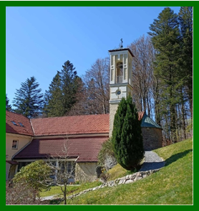
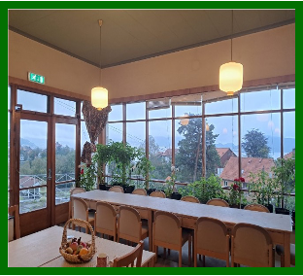
- Because you both desire to be formed and are a catechist: in your home, in your parish, in the world

Our Formation Venue

The retreat convent of
Marias Minde / Vår Frue kirke
Bergen, Norway

Mass will be celebrated daily

This is also where we will come together for formation

Note: Due to the anticipated size of the group and the space itself ~ You will need your own accommodations in Bergen and will need to bring your own lunch and snacks which may be eaten at Marias Minde. Coffee and tea will be provided.
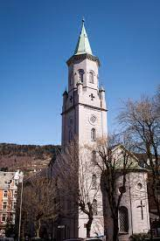
Once you are registered, you will also be provided with information that may help you find a place to stay if you are not a local.

Our Hosting Parish of Saint Paul Menighet
Saint Paul parish is the one and only catholic parish in Bergen, it is a vibrant multilingual parish, consisting of about 20,000 members from over 150 different nationalities, which makes it the biggest parish in Norway. Masses are celebrated throughout the month in 11 different languages. The church is situated in the beautiful coastal city of Bergen, the second largest city in Norway.
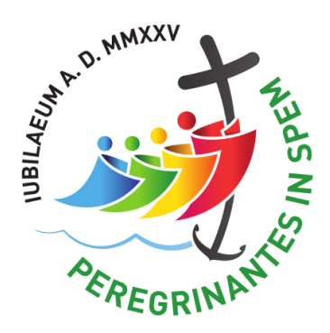
Saint Paul is a designated church for the Jubilee Year of Our Lord MMXXV and as such you may make a pilgrimage to the Church and receive a plenary indulgence under the usual conditions as a pilgrim of hope.
St. Paul Menighet Katolsk kirke i Bergen
https://bergen.katolsk.no/?page_id=905

When will the formation be?
The formation will be offered as an whole, 12 days with Sunday May 3rd off to enjoy Mass and Bergen
These 12 days comprise the whole formation. When you register it will be for all 12 days of the formation. If you have been present for the whole formation you will receive a certificate on the final day from
The United States Association of the Catechesis of the Good Shepherd. https://www.cgsusa.org/

Cost and How and when to register?
We ask you to sign up as soon as possible with the limit 1st of December. . Please register here : https://forms.gle/vG5Gs4dYQLBA77Tu6

The exact amount for payment for the course will depend on the number of participants and the cost of the flight tickets which varies a lot. We will therefore give you now an estimate of the price, which can be between 400 and 500 EUR. If more people join, the price will go even further down.
The cost will cover the stipend and flight tickets for the formation leaders from USA. It does not cover your own food, lodging and materials. You will be asked to make one payment after the limit for registration is reached (and not before).You will through an email be asked to pay the monies via iban in the space of a week so the Formation Team can purchase their tickets. Payment will not be refundable at this point unless the formation has to be canceled by the host. Once you are registered, you will also be provided with information that may help you find a place to stay if you are not a local.

Your registration is a commitment to the formation for yourself and others. If we do not reach the minimum of 20 participants, the formation may have to be canceled. The maximum number of participants for the formation space capacity is 40.

Please spread the word about this rare opportunity in your community!

HOST & Formation Team Members
Reidun Jofrid Kleppestrand is the local host and a member of the Formation Team as a Level I & II formation leader who is working towards becoming an Infant Toddler Formation Leader. Reidun was a participant in the first seminal 0-3 formation in Wales in 2016 - 2017. She is the Catechist coordinator at St Paul parish in Bergen where she is and has worked with children in all levels of CGS for several years. She has a Master of Theology degree, teacher education, with science as subjects and General Catechetical education in addition to CGS. Reidun is married and the mother of 4, teenagers and grown ups.

Elizabeth Calanchini has been/is: 0-3 formation leader for all 23 Seminal Infant Toddler CGS formations; an AMI Montessori directress & guide for children ages 0-12; formed in & has been a catechist for all levels of CGS for over 30 years; hosted/assisted/formed (FL for LT & LI) in all levels for many years: taught in 3 Catholic Montessori schools; a Director of Programs in the school she co-founded; consulted for Catholic Montessori schools & parishes and newly completed a 2.5 year program in Montessori Medical Therapy Training to support those with special needs in inclusive environments.

Mary Beth Palko is formed as a catechist in the Catechesis of the Good Shepherd at Level I, II, III and Infant & Toddler. She has served as a catechist and director in these levels for nearly twenty years. While doing so, she developed a love of passing on the work to the adult as a formation leader in Level I and Level II. She has a Master of Arts in Pastoral Studies Catechesis of the Good Shepherd from Aquinas Institute of Theology. A retired first grade teacher, Mary Beth is married, has three children & a beautiful granddaughter.

